ACTIVIDADES DE CONSOLIDACIÓN

1. Complete the chart with the correct form of be: **is am are**

|  |  |  |
| --- | --- | --- |
| I |  | from Jujuy |
| Mbappé |  | From France |
| You |  | a photographer |
| Canada |  | in North America |
| Oxford |  | a good university in England |

2. Rewrite the sentences in 1 using the short forms ‘s, ‘m and ‘re[1].

3. Write 5 (five) sentences (true or false) about Ajay Kumar, Rosa Perez Lopez, Nicolas Dupont and Gong Yue, correct the false[2]. **EXAMPLE:** Nicolas Dupont is a waiter in France.

False. He’s a waiter in England.

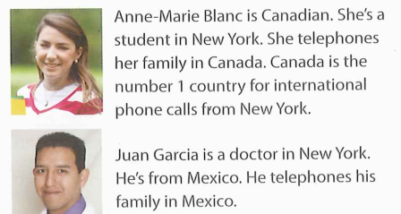4. Read Ann-Marie’s self intro and use it as a model to write about you.[3]

Hi. I’m Anne-Marie Blanc and I’m from Canada. I’m a student and a secretary.

My mobile number is 619-73207 and my work number is 619 - 559001

5. Listen and write the phone numbers.

a. David Medina ………………………….

b. Sarah Connor ………………………….

c. Stephen Carson …………………………..

d. Nicole Johnson …………………………………

1. Reescribir las oraciones en ejercicio 1 usando las formas cortas ´s, ´m y ´re.
2. Escribí 5 oraciones, verdaderas o falsas sobre Ajay Kumar, Rosa, etc., corregí lo falso.
3. Leé la presentación de Ann-Marie y usala como modelo para escribir sobre vos.